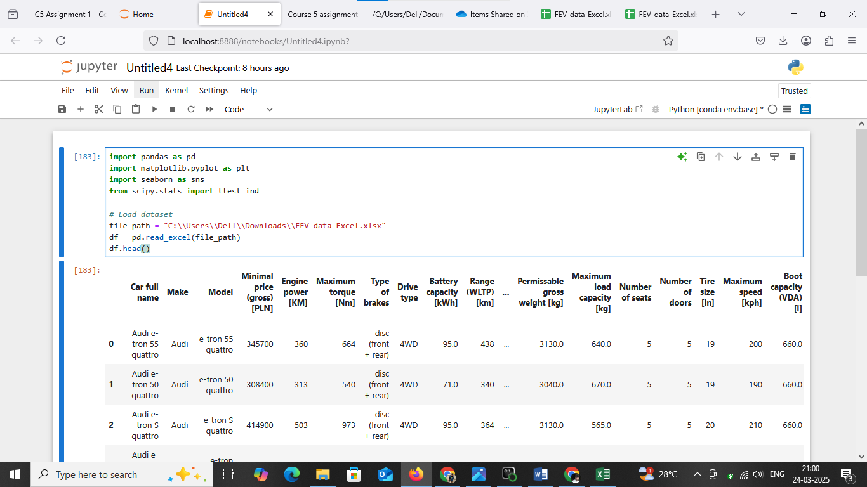

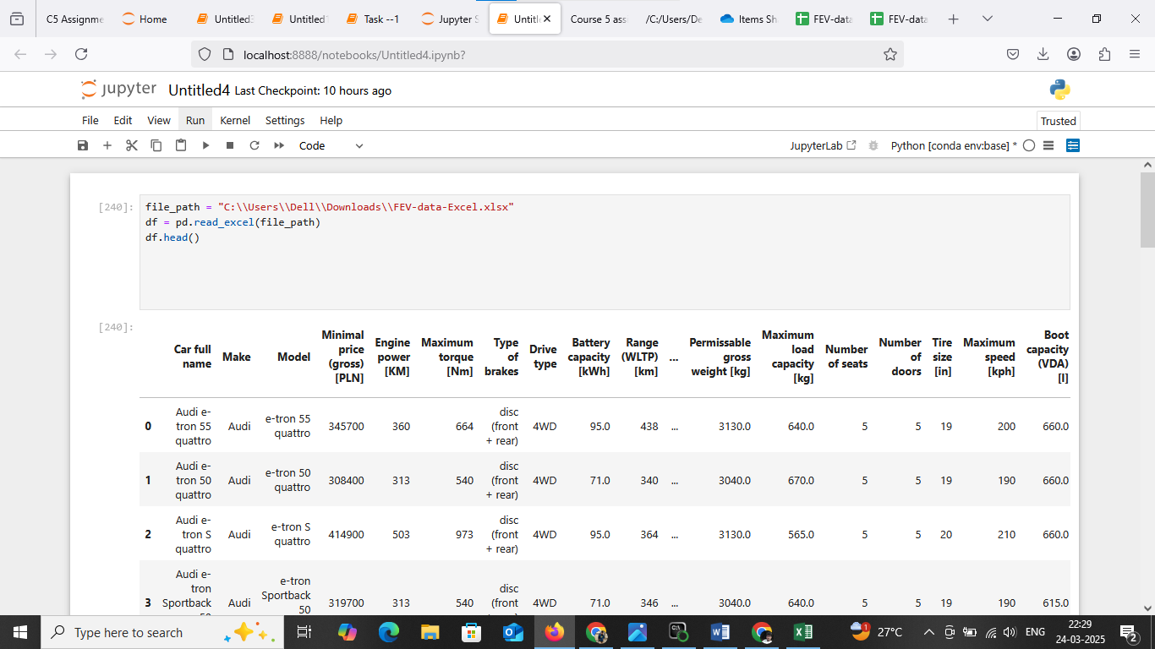

Task 1: A customer has a budget of 350,000 PLN and wants an EV with a minimum range of 400 km.

a) Your task is to filter out EVs that meet these criteria.

b) Group them by the manufacturer (Make).

c) Calculate the average battery capacity for each manufacturer.

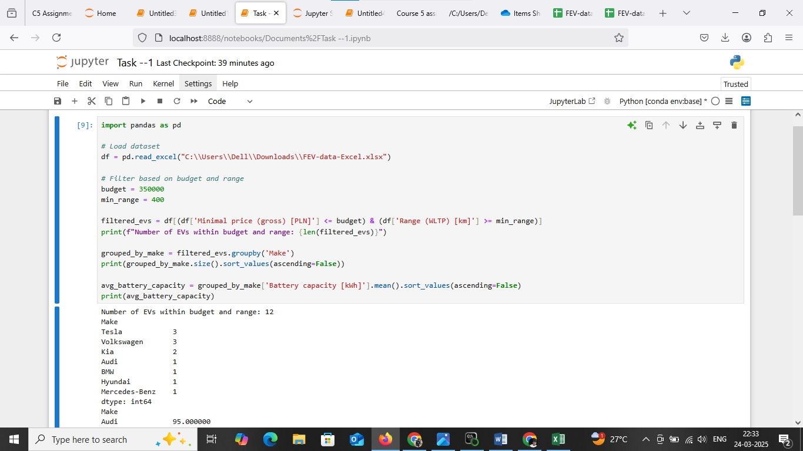

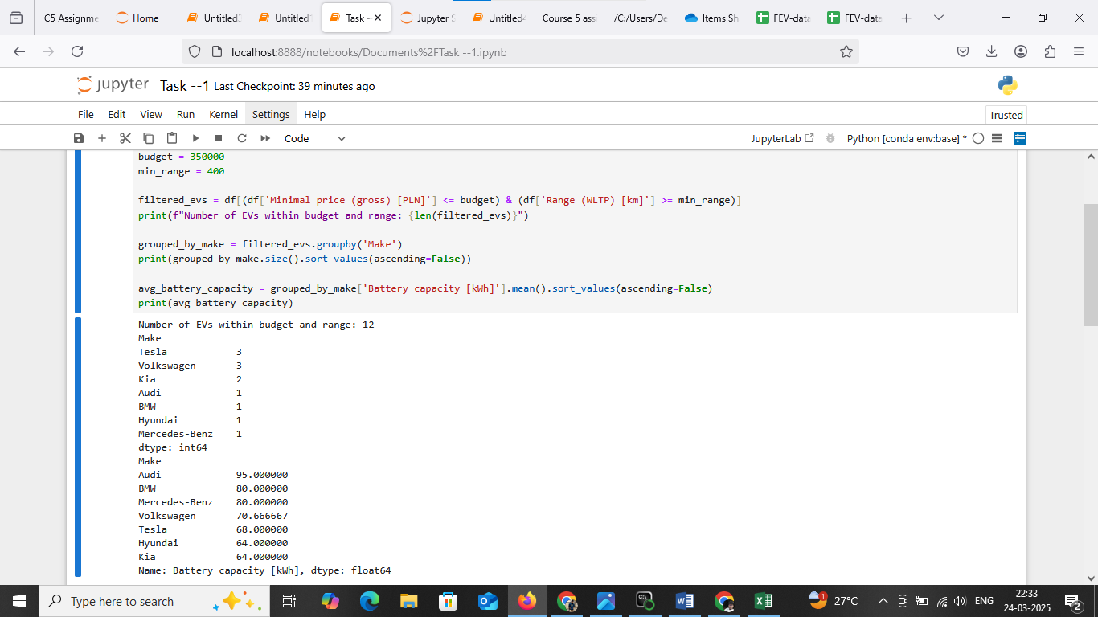

Task 2: You suspect some EVs have unusually high or low energy consumption. Find the outliers in the mean - Energy consumption [kWh/100 km] column.

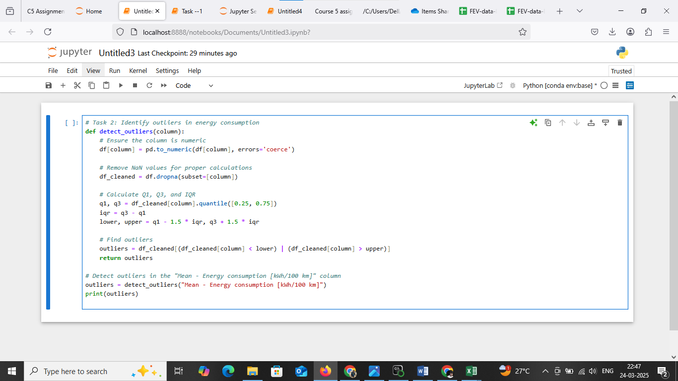

Task 3: Your manager wants to know if there's a strong relationship between battery capacity and range.

a) Create a suitable plot to visualize.

b) Highlight any insights.

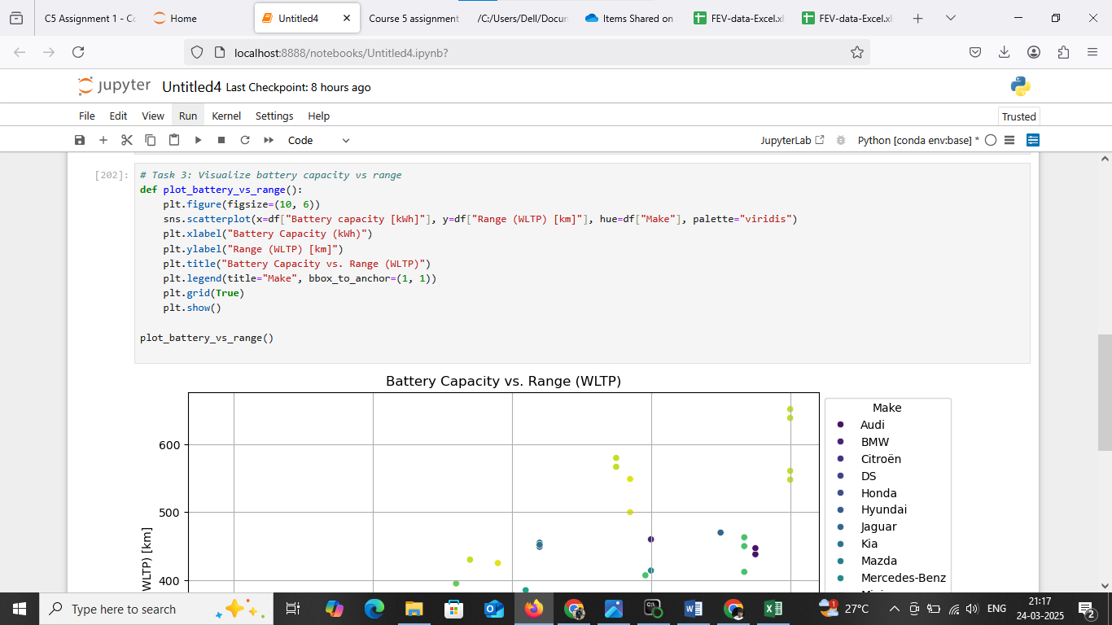

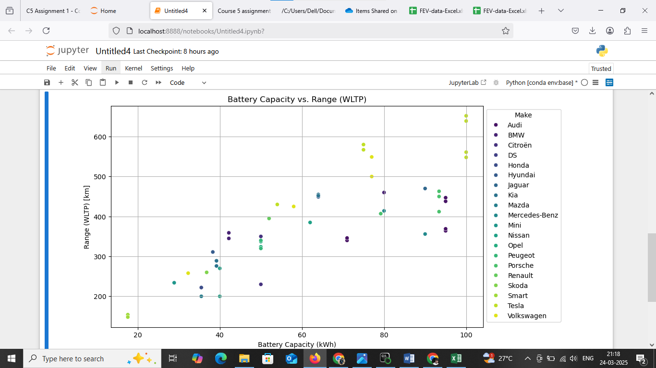

Task 4: Build an EV recommendation class. The class should allow users to input their budget, desired range, and battery capacity. The class should then return the top three EVs matching their criteria.

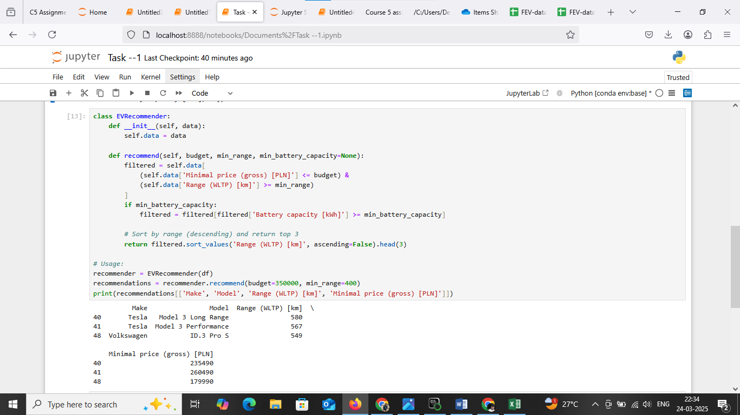

Task 5: Inferential Statistics – Hypothesis Testing: Test whether there is a significant difference in the average Engine power [KM] of vehicles manufactured by two leading manufacturers i.e. Tesla and Audi. What insights can you draw from the test results? Recommendations and Conclusion: Provide actionable insights based on your analysis. (Conduct a two sample t-test using ttest_ind from scipy.stats module)

